Expt.7
Code:
num=(1,2,3,4,5)
print(num)
print("first element:",num[0])
print("last element:",num[4])
print("Lenght of tuple:",len(num))
if(2 in num ):
print("Exisr")

output:
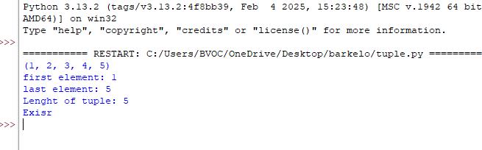

Q2
Code:
tup=(1,2,3,4)
L_list=list(tup)
L_list.append(1)
print(L_list)
tup_updade=tuple(L_list)
print(tup_updade)

output
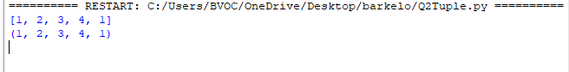

Q3
Code:
L_list=[1,1,2,2,3,4,5,5,6]
S_set=set(L_list)
print(S_set)
output:
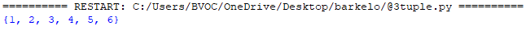

Q4
Code :
A={1,2,3,4,5}
B={4,5,6,7,8}
print(A|B)
print(A&B)
print(A-B)
print(A^B)
output:
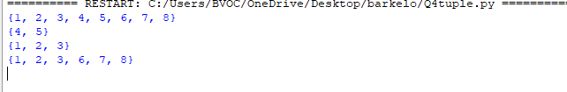

Q5
Code:
mydata={"name":"barkelo","roll_no":"6","marks":"50"}
print(mydata.keys())
print(mydata.values())
print(mydata.items())
mydata["marks"]= "100"
print(mydata)
print(mydata["roll_no"])
mydata["Stream"]="bvoc"
print(mydata)

output:
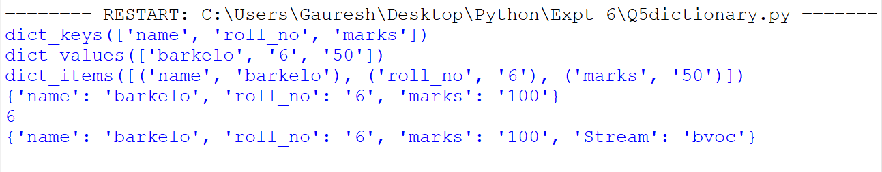

Q6
Code:
my_marks={"python":50,"ct":50,"se":50}
sums=0
for i in my_marks.values():
sums+=i

print(sums)
print(sum(my_marks.values()))
print(max(my_marks.values()))

output:

